*A report on*

***Power Manager Telemetry***

***Submitted for the Intel Unnati Industrial Training Program 2024***

***Team***

**Abhilash K Raj (1NT21IS004)**

**Umang Mehta (1NT21EC164)**

Under the Guidance of

**Dr. Rajesh N**

Professor

Dept. of Electronics and Communication Engineering

**DEPARTMENT OF ELECTRONICS AND COMMUNICATION ENGINEERING**

**YELAHANKA, BENGALURU- 560064**

#### Introduction

In the era of 5G and edge computing, the deployment of devices across different locations has increased, leading to higher power consumption. The government is pushing enterprises and industries to reduce power usage to achieve net-zero power consumption. This project aims to measure and optimize power consumption in systems.

#### Project Objectives

1. Research and identify open-source tools for power measurement.
2. Identify and document the available knobs in a system to measure power.
3. Collect power telemetry data from CPU, memory, NIC, and TDP.
4. Measure and record system power utilization for CPU, NIC, and TDP based on the input parameter of system utilization percentage.
5. Create a report on the power problem, technical approach, and results.

### Project Structure

* **data/**: Directory to store collected telemetry data.
* **src/**: Directory containing source code.
* **notebooks/**: Directory containing Jupyter notebooks for data analysis.
* **main.py**: Main script to run the project.
* **requirements.txt**: Python dependencies.

### Getting Started

1. **Install dependencies**:



1. **Run the main script**:



#### Libraries and Dependencies

The ‘requirements.txt’ file lists the necessary Python libraries for the project. Here is an example list of possible dependencies:

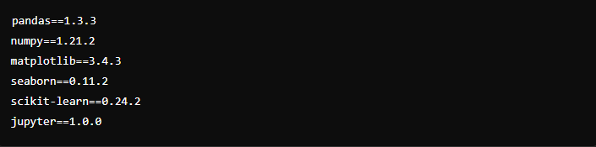

### Code

#### main.pyk

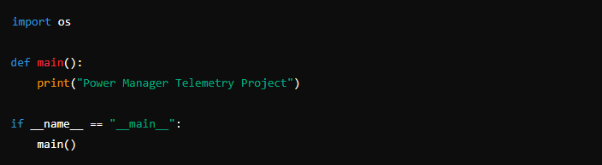

#### Source Code

The ‘src’ directory contains additional scripts responsible for data collection and analysis.

##### src/collect_telemetry.py

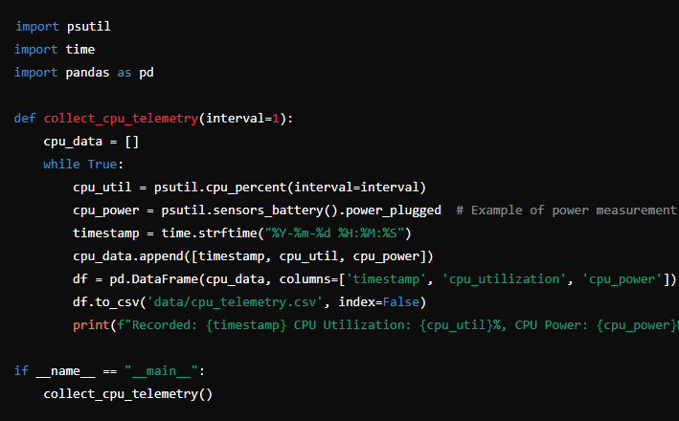

##### src/analyze_telemetry.py

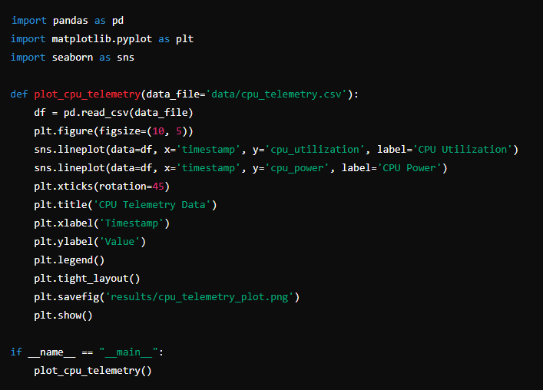

#### Notebooks

* **notebooks/**: Contains Jupyter notebooks used for data analysis. These notebooks perform detailed analysis, visualization, and generate reports based on the telemetry data.

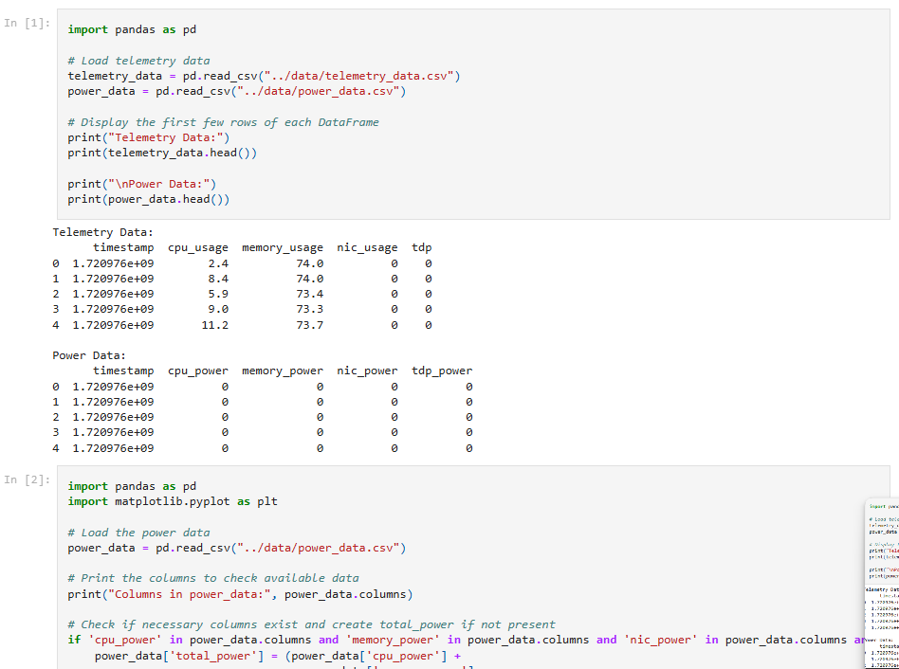 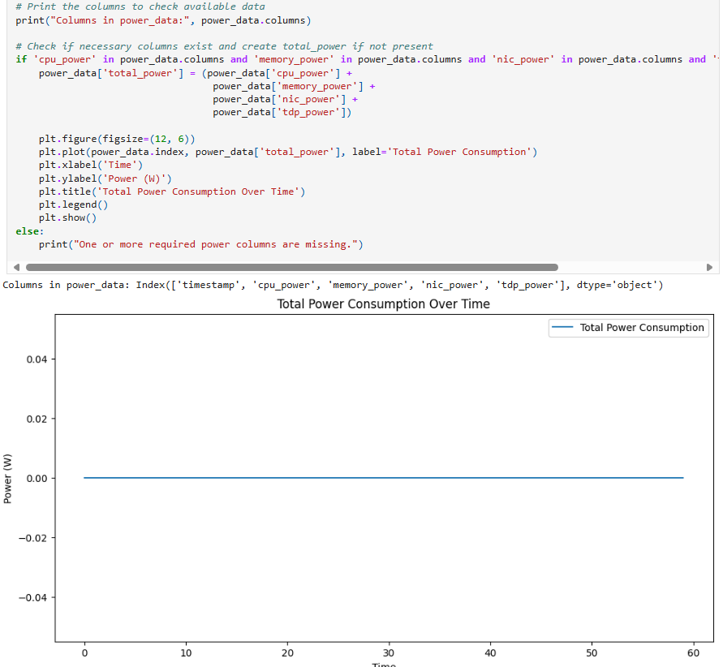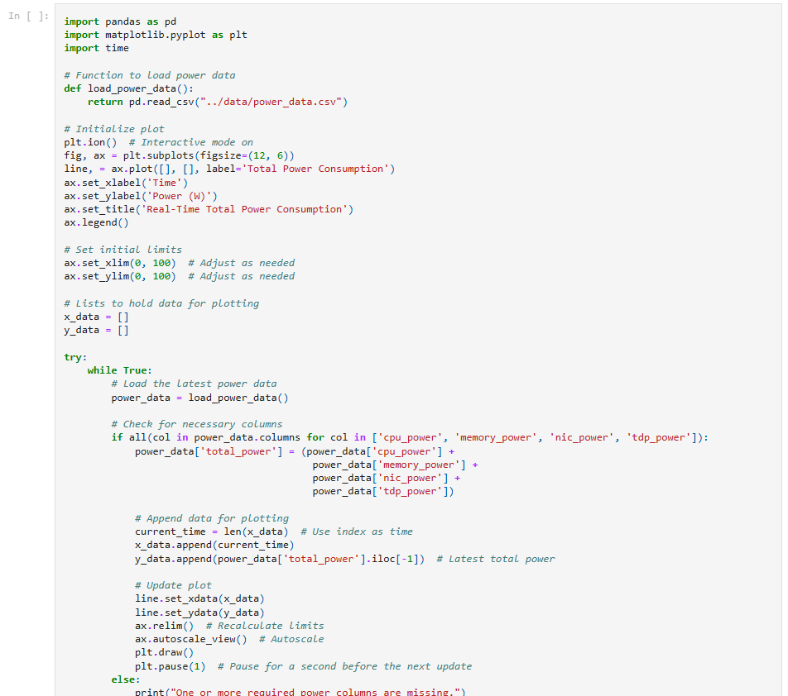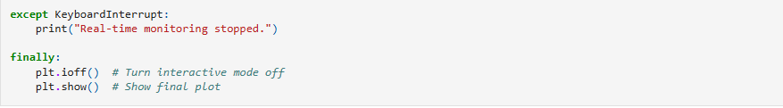

#### Data

#### Power Telemetry Data

The data collected in this project includes metrics from various system components, such as the CPU, memory, and network interface controller (NIC). Below are some examples of the telemetry data:

* **CPU Telemetry**: Includes metrics like CPU utilization, power consumption, and temperature.
* **Memory Telemetry**: Includes metrics like memory usage and power consumption.
* **NIC Telemetry**: Includes metrics like data transfer rates and power consumption.
* **TDP (Thermal Design Power)**: Measures the maximum amount of heat generated by the components that the cooling system in a computer is designed to dissipate.

Example of telemetry data collected (stored in data/ directory):

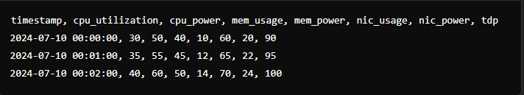

Power data:

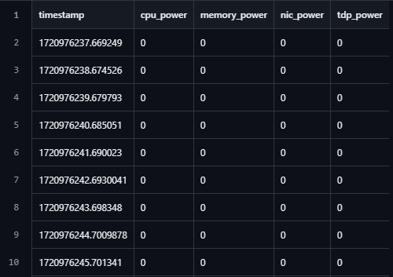

Telemetry data:

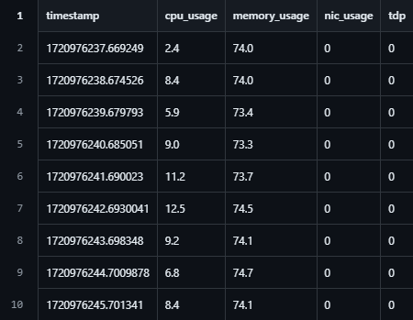

#### Analysis Results

The analysis of the collected telemetry data is performed using Jupyter notebooks located in the notebooks/ directory. The notebooks include visualizations and statistical analysis to identify power consumption trends and potential areas for optimization.

#### Results

* **Power Telemetry Data**: Collected and stored in the data/ directory.
* **Analysis**: Performed using the Jupyter notebooks in the notebooks/ directory. Key insights include power consumption trends, peak usage times, and correlation between system utilization and power consumption.
* **Reports**: Generated based on the data analysis, highlighting power consumption trends and optimization strategies. These reports can guide efforts to reduce power usage and improve system efficiency.

#### Conclusion

This project provides a comprehensive approach to measuring and optimizing power consumption in systems. By leveraging open-source tools and systematic data collection, it aims to contribute to achieving net-zero power consumption in the era of 5G and edge computing.

For more details, visit the [GitHub repository](https://github.com/akera-oo7/power_manager_telemetry).